S/O Ghulam Murtaza  DAT OF BIRTH: 31 May 1977  NATIONALITY: Pakistani  Tel: +92 3005580475 / 3340550055 | House # 340 street # 17 G 15/4 islamabad  E-Mail: rashidmurtaza1@yahoo.com  Passport: AH-0977712 | 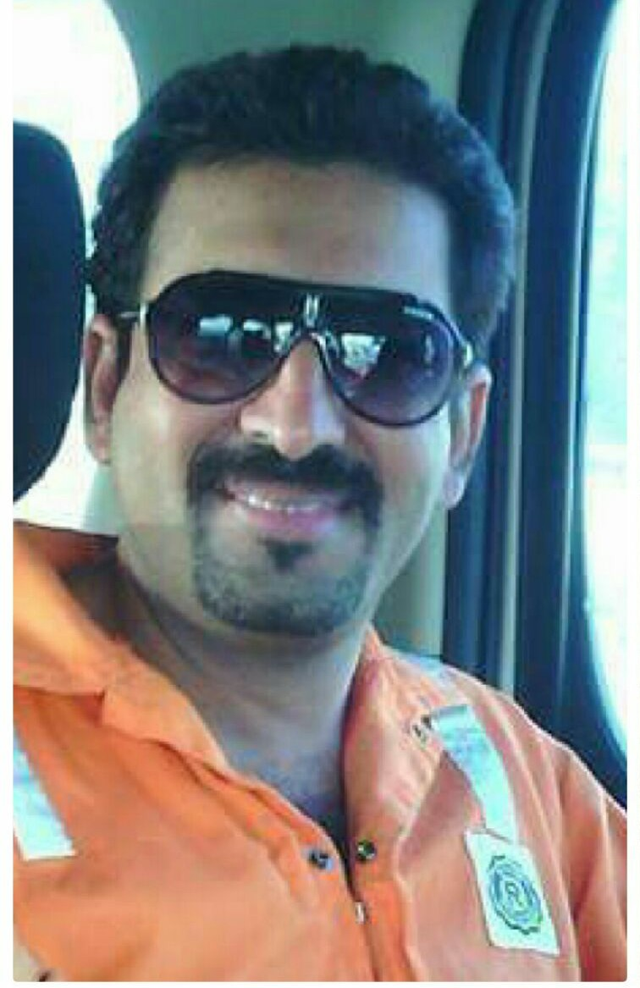
RASHID MURTAZA

CAREER VISION:
I believe in dignity, honesty, sincerity, perfection, teamwork, and commitment. I try my best to achieve standard & quality work results. I always strive for improvement.
To contribute towards the development & growth of dynamic organization where I can utilize my knowledge & skill effectively & efficiently.

EMPLOYEMENT HISTORY:

From To Position Company Location

Apr 2007 Till Now Chief Mechanic Rowan Drilling Offshore Saudia

May 2006 Mar 2007 Chief Mechanic Great Wall Co Pakistan

Mar 2005 Apr 2006 Rig Mechanic Ensco Offshore Dubai

Oct 2002 Jan 2005 Chief Mechanic KCA Deutag Pakistan

Nov 2000 Aug 2002 Rig Mechanic Abunayyan Saudia

Sep 1998 Jul 2000 Junior Mechanic Hakas (Pvt Ltd) Pakistan

EQUIPMENT WORKED WITH:

ENGINE:
- D 398 ( Caterpiller ), 3512 ( Caterpiller ), 3512 B ( Caterpiller ), 3516 B ( Caterpiller ), 3408 ( Caterpiller )

TDS:
1. NOV 4s 750
- Oil well Varco TDS 8SA AC Powered
- Varco 11SA AC Powred
MUD PUMPS:

- National , 8-P-80 , 10-P-120 , 12-P-160
- Bomco Bao Ji F-1600
- Lewco USA 3000 HP
OMNIPURE:

- AGE Omnipure Back Flush System

DRAW WORKS:

- Oil well 2000
- Bomco 1600 HP
- Lewco USA 3000 HP

WATER MAKERS:

- Alfa Level
- Aqua Chemical
3 C treat F D 301-4
AIR COMPRESSER:

- Quincy QSI 370
- Quincy QSI 600

PROFESSIONAL PROFILE:
A resourceful person who has the experience of the oil industry & has taken a professional interest in HSE matters & how they relate to personal protection & maintaining productivity. A team worker, who has the ability & knowl8edge to be able to maintain the professional standards with excellent communication skills involving all personal / companies on the rig site, Reliable, conscientious & committed with profession.

LANGUAGE:

 | READ | WRITE | SPEAK
English | ✓ | ✓ | ✓
ARABIC | ✓ | ✓ | ✓

COMPUTER PROFICIENCY:

Microsoft Windows XP, NT, 2000, 98.
Microsoft Office Word, Excel, Power point, Outlook, Internet.

EDUCATION:
Mechanical Engineering
SSC Rawalpindi Board

MT 110 ELECTRICAL DEVICE CERTIFICATION CERTIFICATE
SAFETY TRAINING:

ROWAN RIG HB 57
BIOSET VALIDITY DATE 10/09/2013
- Helideck Assistant
- Advance Fire Fighting
- Rescue Sea Survival
- PSSR
- Confined Space Entry
- Abrasive Wheels
- 1st Responder / CPR
- H2S (Rutledge)
- Helicopter underwater escape
- (HUET) including EBS
- Self rescue
- First Aid and Hypothermic
- Basic Offshore safety induction emergency training
- Work shop work permit system ( ROWAN Companies)

Under the SMTC GLOBAL Educational Council OPITO

KCA DEUTAG

- H2S
- Fire Fighting

GREAT WALL DRILLING COMPANY

1. H2S
2. Fire Fighting
- First Aid
- Hazard and effect
- HR and HSE

ENSCO

- Advance Fire Fighting
- Rescue Sea Survival
- Confined Space Entry
- 1st Responder / CPR
- H2S (Rutledge)

Under the P.E.C Petroleum Educational Council USA
REFERENCE:

Available on request

